Singing Our Faith **# 451** *“Be Thou My Vision”*

The Good News ***“Shocking Extravagance”***

Bringing Forward God’s Tithes and Our Gifts

*Doxology **# 95 Praise God from whom all blessings flow; praise him, all Creatures here below;** **praise him above, ye heavenly host; praise Father, Son, and Holy Ghost. Amen.**

*Prayer of Thanksgiving

Sharing of Joys and Concerns

The Lord’s Prayer

**Our Father, who art in heaven, hallowed be thy name. Thy kingdom come, Thy will be done on earth as it is in heaven. Give us this day our daily bread and forgive us our trespasses, as we forgive those who trespass against us. And lead us not into temptation, but deliver us from evil. For thine is the kingdom, and the power, and the glory, forever. Amen.**

*Singing Our Faith **# 413** *“A Charge to Keep I Have”*

*Blessing and Dismissal

*Postlude

**Scatter to Serve God & Neighbor**

***Welcome to all!*** *We gather to praise God for the innumerable blessings given to us and to grow deeper in the Spirit. Joyfully, let us lift our hearts to God.*

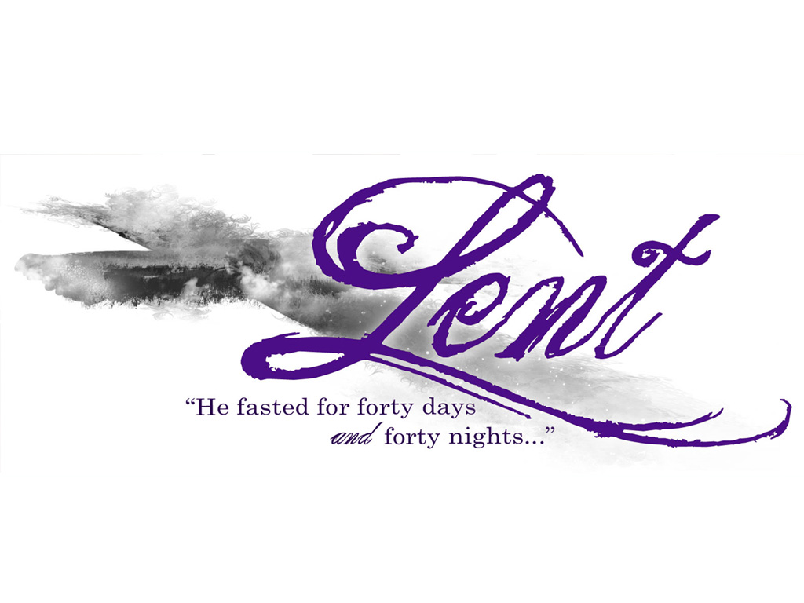



*C* *hestnut Hill*

***United Methodist Church***



*Making disciples of Jesus Christ   
for the transformation of the world.*

*You are welcome at Chestnut Hill UMC.*

4660 Fort Avenue ~ Lynchburg, Virginia 24502

Church: 434-239-8423

Minister’s Cell: 434-944-7723, Minister’s Email: awhite@ves.org

Associate Minister’s Cell: 1-502-489-0200

Associate Minister’s Email: healingsolutions12@gmail.com

Email: [chestnuthillumc@comcast.net](mailto:chestnuthillumc@comcast.net)

On the Web at chestnuthillumc.net

Find us on Facebook: Chestnut Hill United Methodist Church

**

*Chestnut Hill United Methodist Church*

10:30 a.m. ~ March 30, 2025 ~ Fourth Sunday in Lent

Our ministry vision for the Virginia Annual Conference is ***“to be***

***disciples of Jesus Christ who are lifelong learners, who influence others to serve.”***

***Welcome! Join us in worshiping God!***

Prelude

Welcome and Ministry Announcements

*Welcome in the name of Christ our Lord. Please register your attendance, printing your name, address, phone, and email, on the attendance pad provided on your pew. Thank you for silencing cell phones as we gather to worship God.*

Invocation

*Greeting

O Thou, from whom all goodness flows,  
I lift my heart to Thee;  
**In all my sorrows, conflicts, woes,  
Dear Lord, remember me.**

Whenever on my poor, burdened heart  
My sins lie heavily,  
**My pardon speak, new peace impart;  
In love remember me.**

Temptations sore obstruct my way,  
To shake my faith in Thee;  
**O give me strength, Lord, as my day;  
For good remember me.**

Distressed with pain, disease, and grief,  
This feeble body see;  
**Grant patience, rest, and kind relief:  
Hear and remember me.**

When in desertion’s dismal night,  
Thy face I cannot see,  
**Then, Lord, arise with glorious light,  
And still remember me.**

If on my face, for Thy dear name,  
Shame and reproaches be,  
**All hail reproach, and welcome shame,  
If Thou remember me.**

The hour is near; consigned to death,  
I own the just decree;  
**Savior, with my last parting breath  
I’ll cry, Remember me.**

*Singing Our Faith **# 384** *“Love Divine, All Loves Excelling”*

Opening Prayer

**Almighty God, you alone can bring into order the unruly wills and affections of sinners: Grant your people grace to love what you command and desire what you promise; that, among the swift and varied changes of the world, our hearts may surely there be fixed where true joys are to be found; through Jesus Christ our Lord, who lives and reigns with you and the Holy Spirit, one God, now and for ever. Amen.**

Special Music

Greeting Friends and Neighbors

Prayer of Illumination

**Gracious God,** **by the presence of your Holy Spirit,** **bless this our proclamation of your Word** **that we may receive the gift of your grace** **and share it with those who we will meet** **on this journey to which we are called.** **Speak to us this day for we,** **your servants, are listening. Amen.**

Scripture Lesson Luke 15:1-3, 11b-32

The Word of God for the people of God.

**Thanks be to God.**

***\*\*Calendar \*\****

|  |  |  |
| --- | --- | --- |
| Thursday, 4/3 | 10:00 a.m. | *Homeschool Rehearsal* |
|  |  |  |
| Friday, 4/4 | 10:00 a.m. | *Homeschool* |

**For the Grocery Cart:**

**March/April ~** *“Pop-top cans of food and fruit”*. Place donations in the cart in the Commons.

**\*\*\*NOTE:** **Park View Community Missions Clothing Connection** is now collecting **ONLY** Spring and Summer clothes.

**Easter Offering**

Beginning next Sunday, April 6th, we will begin collecting donations for our Easter Offering. Our goal to reach will be $7,000 to be used for the beautification of the front of our church. Envelopes will be provided in the pew racks for the month of April.

**Cards for Homebound Members**

Take a moment to sign the cards for our homebound members/friends that Erin has placed in the Commons.



***DIRECTORY OF CHESTNUT HILL UNITED METHODIST CHURCH***

|  |  |  |  |
| --- | --- | --- | --- |
| Sue Haupert-Johnson | | Richmond Area Resident Bishop | |
| Rev. Dr. Sarah Calvert | | Mountain View District Superintendent | |
| Adam White | | Minister | |
| Erin Long | | Associate Minister | |
| Sharon Mayhew | | Director of Music | |
| Monica Campbell | | Administrative Assistant | |
| Judy Martin | | Bookkeeper | |
| Judy Robertson  Elizabeth Nichols | | Lay Leader  Missionary in Henry County | |



***\*\*Calendar \*\****

|  |  |  |
| --- | --- | --- |
| Thursday, 4/3 | 10:00 a.m. | *Homeschool Rehearsal* |
|  |  |  |
| Friday, 4/4 | 10:00 a.m. | *Homeschool* |

**For the Grocery Cart:**

**March/April ~** *“Pop-top cans of food and fruit”*. Place donations in the cart in the Commons.

**\*\*\*NOTE:** **Park View Community Missions** **Clothing Connection** is now collecting **ONLY** Spring and Summer clothes.

**Easter Offering**

Beginning next Sunday, April 6th, we will begin collecting donations for our Easter Offering. Our goal to reach will be $7,000 to be used for the beautification of the front of our church. Envelopes will be provided in the pew racks for the month of April.

**Cards for Homebound Members**

Take a moment to sign the cards for our homebound members/friends that Erin has placed in the Commons.



***DIRECTORY OF CHESTNUT HILL UNITED METHODIST CHURCH***

|  |  |  |  |
| --- | --- | --- | --- |
| Sue Haupert-Johnson | | Richmond Area Resident Bishop | |
| Rev. Dr. Sarah Calvert | | Mountain View District Superintendent | |
| Adam White | | Minister | |
| Erin Long | | Associate Minister | |
| Sharon Mayhew | | Director of Music | |
| Monica Campbell | | Administrative Assistant | |
| Judy Martin | | Bookkeeper | |
| Judy Robertson  Elizabeth Nichols | | Lay Leader  Missionary in Henry County | |

